Remote Desktop (RDP) to SAPL Computer Lab (How To?)
< Computers Available for Remote Connection listed on Page 2 >

Windows PC | MAC
- Use General VPN to connect to the University network  - Download and install from the IT software distribution https://iac01.ucalgary.ca/SDSWeb  - How to download: https://ucalgary.service-now.com/nav_to.do?uri=/kb_view.do%3Fsysparm_article%3DKB0030073  - How to install: https://ucalgary.service-now.com/nav_to.do?uri=/kb_view.do%3Fsysparm_article%3DKB0030079  - How to connect: https://ucalgary.service-now.com/nav_to.do?uri=/kb_view.do%3Fsysparm_article%3DKB0030088  - Start the Remote Desktop Program  - Click Start  - In the search box type: "Remote Desktop Connection"  - In the Computer box, enter the full computer name of the lab computer.  - Click Connect  - Enter the computer name with the domain (Example: SH105M04.uc.ucalgary.ca) which you would like to connect (like picture below).  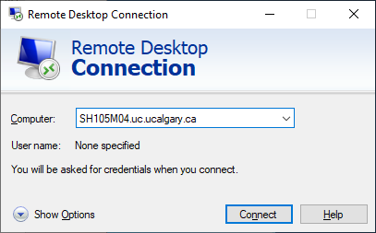  - Enter your IT username and password when prompted.  - Remember to Disconnect ONLY when done. | - Use General VPN to connect to the University network  - Download and install from the IT software distribution https://iac01.ucalgary.ca/SDSWeb  - How to download: https://ucalgary.service-now.com/nav_to.do?uri=/kb_view.do%3Fsysparm_article%3DKB0030073  - How to install: https://ucalgary.service-now.com/nav_to.do?uri=/kb_view.do%3Fsysparm_article%3DKB0030079  - How to connect: https://ucalgary.service-now.com/nav_to.do?uri=%2Fkb_view.do%3Fsysparm_article%3DKB0030213  - Install “Microsoft Remote Desktop 10” from the Apple App Store  - Start the Microsoft Remote Desktop Application  - In Applications launch “Microsoft Remote Desktop”  - In the Connection Center, click +, then select Add PC  - In the “PC name:” box, enter the full computer name of the lab computer. (Example: SH105M04.uc.ucalgary.ca)  - Select Add  - Right Click on the Computer and select “Connect”  - Enter your IT username and password when prompted.  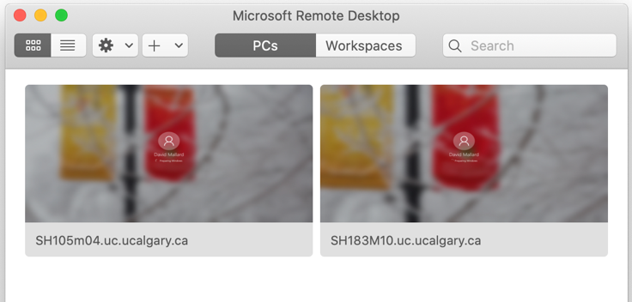  - Remember to sign out when done. Remember to Disconnect ONLY when done.

Computers Available for Remote Connection:
- PF217011.uc.ucalgary.ca
- PF217012.uc.ucalgary.ca
- PF217015.uc.ucalgary.ca thru PF217017.uc.ucalgary.ca
- PF217021.uc.ucalgary.ca thru PF217027.uc.ucalgary.ca
- PF217031.uc.ucalgary.ca thru PF217037.uc.ucalgary.ca
- PF217041.uc.ucalgary.ca thru PF217047.uc.ucalgary.ca
- PF217051.uc.ucalgary.ca thru PF217053.uc.ucalgary.ca

